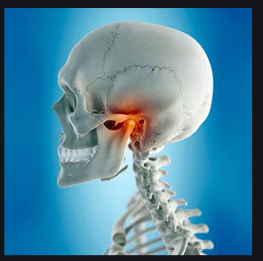
Student Name
Institution
Course Name: course number
Name of instructor
Assignment due date

Temporomandibular Joint Disorders
Temporomandibular joint (TMJ) disorder is a widespread disorder affecting most people in society. Many people complain about pain injury, grinding teeth, and arthritis, which commonly triggers diseases. Others try to read to understand the disorder, but they end up not understanding it completely. This paper discusses the temporomandibular joint (TMJ) disorder and how effective leadership and computer technology can be used to manage the disorder.
The temporomandibular joint disorder (TMJ) is a problem relating to chewing muscles and joints that connect the lower jaw to the skull. The temporomandibular joints collaborate with various jaw muscles and ligaments to enable the mouth's opening and closing. Also, through the combination, an individual can chew, swallow, and speak. Some of the symptoms of the disorder include, pain in the jaws, pain around the ears, difficulty in chewing, and pain on the face muscles. There are a number of factors that causes temporomandibular joint disorder. Due to the joints function combination, some parts of the joint's bones are covered with cartilage, and the small shock-absorbing disk separates them to keep smooth movement. This interaction form basis for the cause of the disorders. When the disk moves out of its proper alignment, there is eroding that causes severe joint pain. It can also be caused by damage to the joint cartilage, which is common in arthritis. The injury causes the disorder in the joint. Finally, the condition may occur if an impact or a blow is damaging the joint (Mayo Clinic, 2020).
Effective patient care during treatment of the disorder is critical. However, there could be concerns in the management of healthcare providers tasked with patient care. Some of the problems could be poor decision making and competence recognition. Good leadership incorporates the planning and adoption of a suitable communication mechanism to promote efficiency. It also helps to enhance good cohesion among the healthcare staff. The computation of the coordination problem analysis helps to get clues to support leadership through the cognitive process. Coordination enables one to enhance effectiveness and efficiency of patient care (Van et al., 2020, pg. 184).
Trying to determine the distinct causes of temporomandibular joint disorder can form a basis for future research and revolution. The computer revolution brought with it a new way of getting things done. There were two computer designs group, which include the minicomputer vendor and general data corporation. This knowledge can facilitate research on the causes and management if TMJ. Such innovations could go a long way in the management of disorders like TMJ (Kidder, 2020, pg. 15).
TMJ disorder is a severe disorder due to the victims' experience. It has various causes such as jaw injury, arthritis, and grinding; some are habitual hindering proper treatment measures. Effective leadership and working for innovation can contribute to efficiency and effectiveness in the diagnosis and management of the disorder.

References
Kidder, T. (1981). The Soul of a Machine. Little, Brown.
Mayo Clinic. (2020). Retrieved 21 October 2020, from https://www.mayoclinic.org/
Van Vugt, M., Hogan, R., & Kaiser, R. B. (2008). Leadership, followership, and evolution: Some lessons from the past. American Psychologist, 63(3), 182.

